# Fe Lattice parameters Review:

## Fe-10%Si lattice parameter as measured by Matthias Gutmann, SXD 2017-04-29 (SXD29925 - SXD29882) from Bragg peak positions (T=8K):

The sample tip (narrow part): a = 2.8459 +/- 0.0007 Angstroms

The sample bulk: a = 2.8438 +/- 0.0010 Angstroms

The value from literature (using interpolation over T and Si contents):

a = 2.8404+0.0003 Angstroms

## Fe-10%Si lattice parameter derived from aligning the sample from inelastic experiment, magnetic excitations. Horace fitting (T=8K):

Ei=200mEv; dE=[70-80]mEv ; a = 2.846 +/- 0.006 Angstroms

(see https://github.com/abuts/Fe/tree/master/2017June/fix_Ei200.m)

Ei=400mEv; dE=[80-90]mEv; a = 2.853 +/- 0.0033 Angstroms

(see https://github.com/abuts/Fe/tree/master/2017June/fix_Ei400.m)

## Publications:

### Equation of State for Fe9Wt%Si 1:

Pure iron T=279K; P=0GPA: a=2.8654(4) Angstroms (V= 23.526(11))

Fe0.91Si0.09 (Wt%) T=279K; P=0GPA a= 2.8429(8) Angstroms (V= 22.976(20))

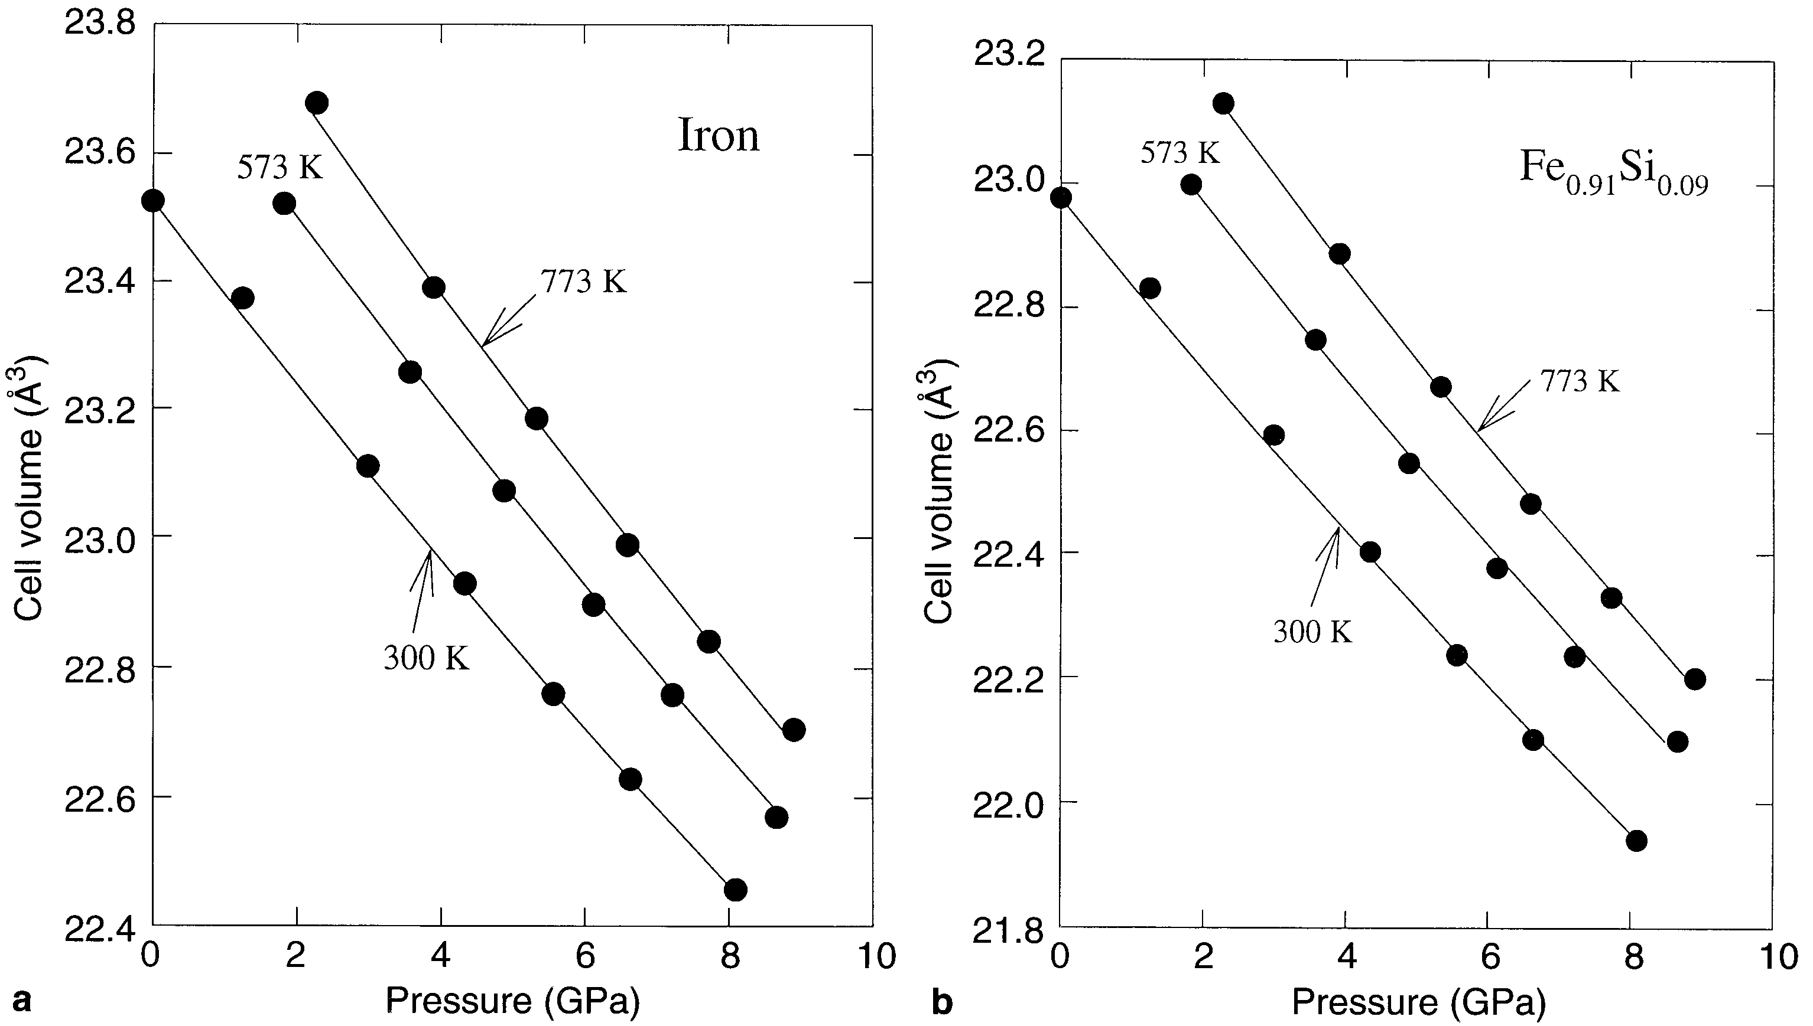

### Lattice parameters of Fe-Si alloy single crystals2

Lattice parameters of single crystals of pure iron and three Fe-Si alloys with Si concentration < 7 at% are measured using three different X-ray techniques, namely the ratio, Bond and triple crystal diffractometer methods. The lattice parameter of pure iron is found to be a = (0.286652 ± 0.000002) nm. In Fe-Si alloys it decreases with increasing Si concentration with the slope Δa/Δc = −0.000069 nm/at% Si. T measured is 22C

a = 2.8665-0.00069*(mFe/mSi*10%(Wt)) = 2.8665 - 0.0134 = 2.8531 Angstroms. (Room temperature (295K))

Article suggests to measure Si contents from the lattice parameters.

### Equation of state of iron–silicon alloys to megabar pressure3

Fe-8.7 wt% Si T=298K a=2.8437(3) Angstroms

### The Lattice Expansion of Iron4

The lattice spacing of high-purity iron have been measured accurately between 20 and 1502 degrees C. The results, together with previous low-temperature data, give data between the absolute zero and the melting-point (1534 degrees C). The thermal expansions of the lattice and of bulk metal are in good agreement over the temperature range for which the latter has been studied accurately. At the A2 point, there is no discontinuity in the lattice spacing. In contrast to the work of some previous investigators, we have found no observable difference between the coefficients of expansion of the lattice immediately above and below the A2 point, and the results suggest that the forces responsible for ferromagnetism do not affect the interatomic distances by more than 1 part in 10000. At the A3 point, the $α→γ$ transformation is accompanied by an increase in the interatomic distance which, when expressed as a percentage change, is slightly less than the decrease in interatomic distance during the $γ→δ$ change at the A4 point. The change in bond length calculated by the Pauling equation for the change ( $f.c.c↔b.c.c$) lies between the observed values for the A3 and A4 points, and the accuracy of the equation is confirmed.



|  |  |  |  |
| --- | --- | --- | --- |
| T | Volume |  | Lattice par |
| 1189 | 12.175 |  | 2.8985 |
| 1175 | 12.1684 |  | 2.8979 |
| 1120 | 12.1347 |  | 2.8953 |
| 1060 | 12.108 |  | 2.8931 |
| 921 | 12.0304 |  | 2.8869 |
| 822 | 11.9742 |  | 2.8824 |
| 722 | 11.9199 |  | 2.8781 |
| 623 | 11.8678 |  | 2.8739 |
| 513 | 11.8104 |  | 2.8692 |
| 293 | 11.7024 |  | 2.8605 |
| 225 | 11.6760 |  | 2.8583 |
| 131 | 11.6460 |  | 2.8559 |
| 92 | 11.6360 |  | 2.8550 |
| 73 | 11.6330 |  | 2.8548 |
| 20 | 11.6310 |  | 2.8546 |

Thermal expansion from experiment above can be fitted by 3th order polynomial with parameters in formula: a =p(4-n)*Tn equal: p(1) = -1.7864e-11; p(2) = 4.2359e-08; p(3) = 1.2255e-05; p(4) = 2.8538;



According to this polynomial, the lattice parameter of pure iron at T=8K a= 2.8538+/-0.0003 Angstrom (polynomial fitting of the table above with Matlab – the routine for fitting:

https://github.com/abuts/Fe/blob/master/2018Dec/FeT_expansion.m )

Interpolation of this number onto 10Wt% Si alloy gives:

a = a0-0.00069*(mFe/mSi*10%(Wt)) = a0-0.0134 = 2.8404+/-0.0003

### Iron — Thermal Expansion5

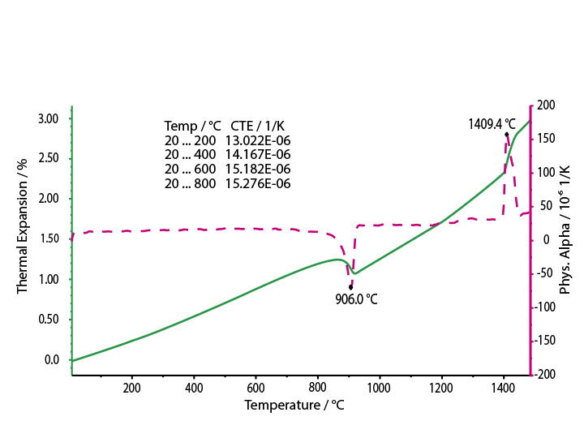

a = 2.843+(T-T0)*1.4*10-5 *(da/a) = 2.843-0.004 = 2.839 Angstrom

## References

1. Zhang, J. & Guyot, F. Thermal equation of state of iron and Fe0.91Si0.09. *Phys. Chem. Miner.* **26,** 206–211 (1999).

2. Polcarová, M., Kadečková, S., Bra̧dler, J., Godwod, K. & Ba̧k-misiuk, J. Lattice parameters of Fe-Si alloy single crystals. *Phys. Status Solidi A* **106,** 17–23 (1988).

3. Hirao, N., Ohtani, E., Kondo, T. & Kikegawa, T. Equation of state of iron–silicon alloys to megabar pressure. *Phys. Chem. Miner.* **31,** 329–336 (2004).

4. Basinski, Z. S., Hume-Rothery, W. & Sutton, A. L. The Lattice Expansion of Iron. *Proc. R. Soc. Lond. Ser. Math. Phys. Sci.* **229,** 459 (1955).

5. Iron — Thermal Expansion - NETZSCH Analyzing & Testing. Available at: https://www.netzsch-thermal-analysis.com/en/materials-applications/metals-alloys/iron-thermal-expansion/. (Accessed: 21st August 2017)